SY 23-24 School Action Plan (West Division Office)

Campus | Welch Middle School
Principal | Dr. Deshonta Everett
Grades Served | 6th – 8th
Enrollment | 508
The timeline for School Action Plan submission can be found below:
- September 1: Principal emails Action Plan to Feeder EDs.
- September 4: Principal receives Action Plan with feedback from Feeder EDs.
- September 8: Principal uploads final copy of Action Plan in West Division SharePoint.
Key Action Guide – Use as a reference to assist with writing the Key Action statements.
Connection to District Plan – Use as a reference for the Connection to the District Plan.

Needs Assessment Goals and Priorities Indicators of Success
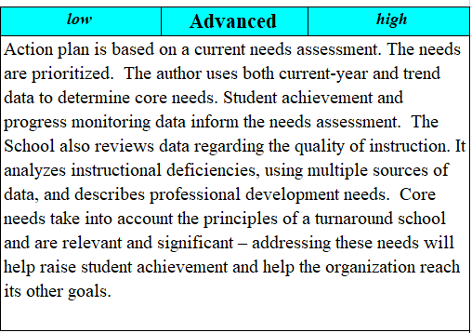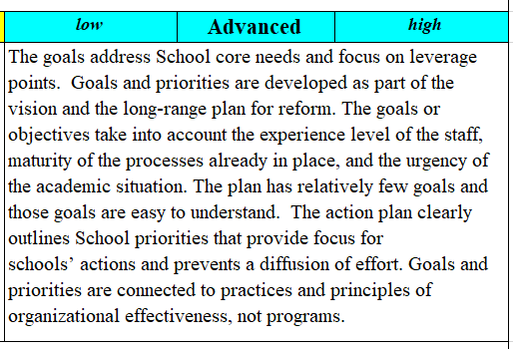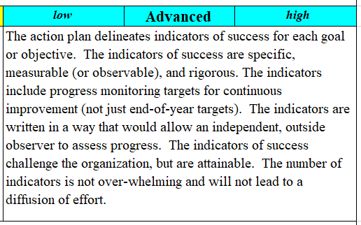

Specific Actions Connection to District Plan Systems Thinking
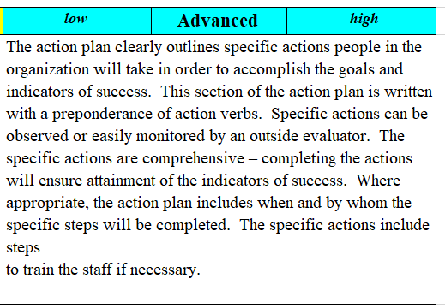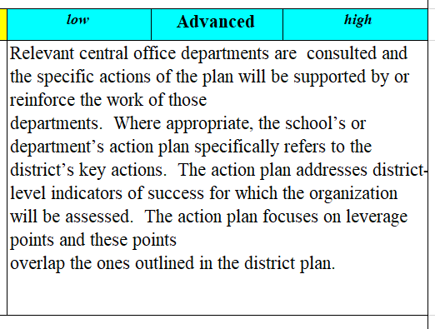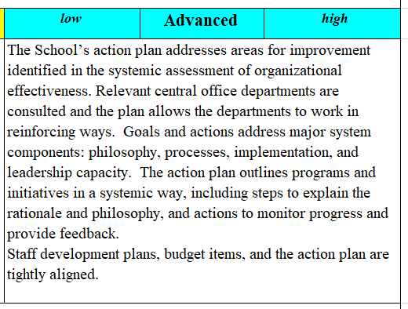

Key Action #1 | Key Action for SPED: Ensure all students receive high quality instruction focused on individualized needs in the regular education setting, unless a student has a significant disability which requires a unique setting and instructions for success.
 | Needs Assessment with Data and Rationale: Data highlight significant gaps in performance between students served by special education and their non-disabled peers. Based on the data from STAAR 2021-22 (still awaiting TAPR for 22-23), students receiving special education services rated 39% Approaches, 27% Meets, and 17% Masters. This is a slight 2 to 5 percent increase from the previous year.
Goals and Priorities:
- Ensure all students with disabilities are included, respected, and valued, enabling them to access course content, fully participate in learning activities, and demonstrate their knowledge and strengths.
- Teach for meaning and mastery using a rigorous, relevant curriculum ensuring equity of access for all students with disabilities.
- Providing learning opportunities according to each diverse learner’s unique needs.
- Hold high expectations for students with disabilities to succeed in regular and advance courses with appropriate support.
- Foster partnerships with families, community, and staff to support the success of students with disabilities.

 | Indicator of Success: 45% of students who receive special education services will achieve at the approaches level or higher on STAAR 2023-24 in Reading and Math.
Specific Actions:
School leaders
- The campus CTC will administer the MAP progress monitoring tool for Math and Reading 3 times per school term (BOY, MOY, EOY).
- The administrator over the Special Education department will meet with the department chair frequently to ensure compliance.
- The Dean of Instruction, Assistant Principals, and Teacher Specialists will monitor, analyze, and provide feedback on lesson plans to ensure students receive high quality instruction.
- The Principal, Dean of Instruction, Assistant Principals, and Teacher Specialists will seek out, facilitate, and present professional development relevant to campus needs concerning special education on an as-needed basis.
- The Principal, Dean of Instruction, and Teacher Specialists will implement a multi-tiered system of support that includes high quality first instruction followed up with flexible models of intervention based on individual student need.

School Staff
- Co-Teachers, Resource Teachers, and Classroom Teachers will collaboratively plan, facilitate small groups, present HQI, and ensure students receive the individualized accommodations required.
- Classroom Teachers and Co-Teachers will attend ARD meetings where they will report on the students’ current level of functioning, recommend accommodations, and answer questions regarding academic and behavior.
- Classroom Teachers and Co-Teachers will document the adherence to students’ FIE/IEP plans and continuously plan based on evidence of student’s advancement and/or failure to meet academic/behavior goals.
 | Connection to District Plan: Core Value #6 – Reduce inequities inherent in the education system; Priority Area #5 – Improve SPED Services

Key Action #2 | Key Action for HQI  Develop teacher capacity in effectively delivering rigorous Good, First Tier I Instruction to ensure effective implementation of HQI.
 | Needs Assessment with Data and Rationale: Based on STAAR 2022-23 data, 12% and 29% of 6th graders scored Meets in math and reading respectively; 7% and 29% of 7th graders; and 6% and 28% of 8th graders. 8th graders scored 10% and 14% Meets in science and social studies respectively.
 | Goals and Priorities: To develop teacher capacity that ensures initial, good, Tier I instruction is presented to all students with the use of research based HQIM, Multiple Response Strategies, and Interventions.
- Indicator of Success: 70% of teachers will receive a 1.5 or higher on SPOT Observation in purposeful instruction by December 2023 and 2.5 or higher by May 2024.
- 40% of all students will perform at the Meets level or higher on campus, district, and state assessments (STAAR) in Reading and Math.
- At least 45% of Emergent Bilingual students will progress at least one proficiency level on TELPAS listening, speaking, and reading.
Specific Actions:
School leaders
- To ensure daily quality instruction, assistant principals and teacher specialists will develop an instructional block breakdown for each core content area that includes each element of the lesson cycle, time stamps, instructional considerations and rubric aligned to the HISD SPOT Observation Form.
- As an additional means of support, the principal, assistant principals, and teacher specialists will provide teachers instructional feedback on the following domains to address the level of rigor in each: lesson objective, demonstration of learning, purposeful instruction, and engagement.
- The assistant principals and teacher specialists will review and provide feedback on weekly lesson plans to specifically address the rigor and alignment of lesson objectives, demonstrations of learning, instructional strategies/activities, student engagement activities (including MRS), assessments (formative/summative), and differentiated instruction for Special Education students.
- During department or grade level planning, assistant principals and teacher specialists will model specific instructional strategies to assist teachers in providing more rigorous instruction, increased student engagement (goal set at 100%), and questioning techniques to allow students to use their higher-level thinking skills.
- During weekly PLC meetings, assistant principals and teacher specialists will facilitate At-Bats to address the level of rigor in lesson objectives, demonstration of learning, purposeful instruction, and student engagement (level of rigor in checking for understanding questions)

School Staff
- Teachers will adhere to the 15 HISD Ready Characteristics.
- Core content teachers will implement the instructional block breakdown for their content and adhere to campus instructional expectations for each element of the lesson cycle.
- Teachers will adjust and implement instructional strategies to reflect the feedback provided by their appraiser on SPOT observations and through collaborative department planning to address lesson objective, demonstration of learning, purposeful instruction, and engagement.
- Based on lesson plan feedback provided by appraisers, teachers will adjust lesson plans and implement changes in future lessons to address rigor, alignment, differentiated instruction, instructional strategies, interventions, and formative and summative assessments.
- During content planning meetings and PLC meetings, teachers will engage in At-Bats to practice instructional delivery and receive feedback on the level of rigor in the lesson around the lesson objective, demonstration, purpose instruction and student engagement (MRS strategies).
- Teachers will implement instructional strategies, including higher-level questioning techniques and best teaching strategies, based on the professional development sessions facilitated by the campus principal and administrative team.

 | Connection to District Plan: Addresses priority #2 (Improve the Quality of Instruction) of HISD’s 11 Priority Areas; Core Value #2 (Effective teachers make the most difference); #4 of HISD Ready Characteristics (Push rigor and relevance); #14 -- Collaborate

Key Action #3 | Key Action for Discretionary Item:  Effectively implement the 2023-2024 WMS School Culture Plan to improve student discipline.
 | Needs Assessment with Data and Rationale: To continue a decrease in the number of behavior incidents occurring on the campus. Students who know they are accountable for their actions both in and out of the classroom tend to increase their academic performance.
 | Goals and Priorities: (1) To teach students to be in control of themselves and to choose socially and morally responsible behavior; and (2) To implement and execute a comprehensive school-wide plan that consists of a range of evidence-based strategies and techniques that develops self-discipline, prevents misbehavior, corrects misbehavior, and remediates and responds to serious and chronic behavior problems.
- Indicator of Success: By May 2024, there will be at least a 10% reduction in office referrals from the previous year by implementing preventive behavior interventions to address Level II and Level III infractions.
- The number of in-school and out-of-school suspensions will decrease 20% from the previous school year.
- At least 85% of the teachers will receive a 2 or higher on the SPOT Observation form by December 2023 and 95% will receive 2.5 or higher by May 2024.

Specific Actions:
School leaders
- The assistant principals will facilitate professional development to teachers/staff over the 2023-2024 Student Culture/Discipline plan, and train teachers on the referral process. (How to properly complete and submit referral.)
- Grade level administrators will monitor and track the amount/type of referral teachers are writing monthly via campus google doc.
- Grade level administrators will run weekly attendance and discipline reports in PowerSchool to monitor the number of out-of-school suspensions and in-school suspensions occurring weekly and discuss intervention options for students with recurring behavioral concerns.
- The grade-level administrators will form a Student Support Team (SST) consisting of grade level admin, counselors, wraparound specialist, attendance clerk, SIR clerk, SPED teacher, etc. to identify Tier II discipline students to provide support. The SST Team will meet bi-weekly to discuss individual students and steps to provide support.
- The Principal, Dean of Instruction, Teacher Specialists, and Grade-Level Assistant Principals will provide de-escalation training and support for teachers to deal with challenging student behaviors.
- Fun Fridays and Synergy Rallies will be held to cultivate a culture of inclusion and a way to incentivize good behavior.

School Staff
- All teachers and staff will attend training/PD on Student Culture/Discipline plan during August preservice.
- All teachers will develop a classroom management plan with expectations and consequences and share with parents.
- All teachers will implement the HISD Student Code of Conduct and Welch Middle School Student Culture plan with fidelity.
- All teachers will attend de-escalation training and implement strategies to deal with challenging behaviors.
- For students that exhibit continuous misbehavior, teachers will recommend students to the SST team to review for additional SEL support.
- All staff will use Class DoJo to incentivize good behavior.
 | Connection to District Plan: Core Value #3 – Hold students and ourselves to high expectations; Core Value #6 – Reduce inequities inherent in the education system; #11 of HISD Ready Characteristics (Manage the classrooms to follow three rules of school: No disruptions, no disrespect, and no bullying.)

Key Action #4 | Key Action for Discretionary Item:  Increase student engagement and progress monitoring (checking for understanding) by implementing Multiple Response Strategies
Needs Assessment with Data and Rationale:
Checking for understanding (CFU) during class keeps learners engaged and accountable for their learning. This provides real time data which is essential for teacher reflection regarding the lesson and students who are excelling or struggling to understand. It guides the teacher’s adjustments to instruction.
 | Goals and Priorities: To ensure all students master the concepts taught and can score 80% on the Demonstration of Learning (DOL).
- Indicator of Success:
- By October 2023, 60% of teachers receive a “2” or higher on Student Engagement on the SPOT observation form. This percentage increases to 95% by March 2024.
- By mid-November 2023, at least 90% of students in each class will appropriately respond to CFU questions by utilizing the Multiple Response Strategies/Lead4Ward Strategies provided by the teacher. This percentage will increase to 90% by April 2024.
- By September 2023, annotated lesson plans will reflect at 100% stopping points for the teacher to stop at intervals during the lesson to ask a pre-planned CFU questions and use an MRS strategy to engage the students.

Specific Actions:
School leaders
- Assistant principals and teacher specialists will train teachers on the Multiple Response Strategies during district and campus professional development days.
- During PLC meetings, grade level meetings, and faculty meetings, assistant principals and teacher specialists will model using a variety of MRS strategies to promote ongoing learning and exposure for teachers to implement in the classrooms.
- The principal, assistant principals, and teacher specialists will conduct effective PLC’s that focus on data and specific instructional strategies to improve teacher practice that leads to increased student engagement.

School Staff
- Teachers will attend the district and campus professional development training on Multiple Response Strategies.
- Teachers will implement Multiple Response Strategies a minimum of 4 times during the lesson using STAAR formatted CFU questions.
- During PLC teachers will engage in ongoing PD, practice (At-Bats) and implementation of Multiple Response strategies and other effective engagement strategies
- Teachers will implement feedback in future lessons as addressed on each Spot Observation on student engagement and on Multiple Response Strategies.
 | Connection to District Plan: HISD Priority Area #2 – Improve the Quality of Instruction; HISD Ready Characteristic #13 – Know where students are academically and emotionally.

